REMEMBERING OUR COMPANIONS IN RUSSIA
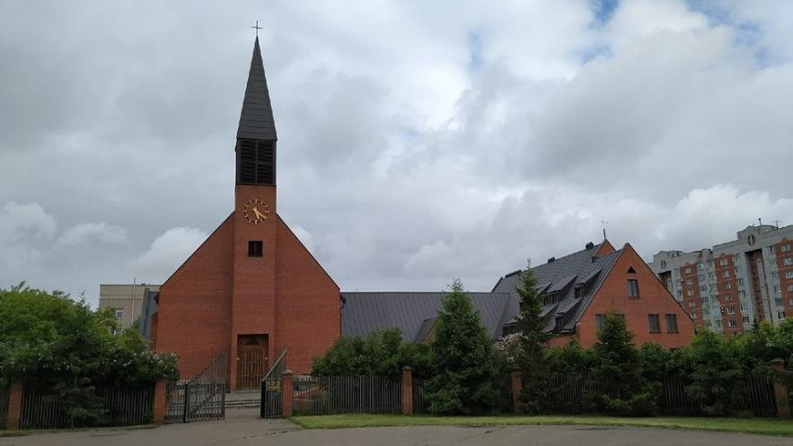
Figure 1The headquarters of the Lutheran Synod of the Urals, Siberia and the Far East located in Omsk, Russia.
By resolution of the Central States Synod Assembly, Sunday, October 5th was designated as the Sunday to remember our companion synod, the Lutheran synod of the Urals, Siberia and the Far East of Russia. While the war in Ukraine has resulted in Missionary Bradn Buerkle and family having to leave Russia and strained our relationship in other ways, it has not broken that relationship. We remain in touch with our cousin Christians in Russia by email and zoom calls. The most recent newsletter from Bishop Alexander Scheiermann is available on the Companion Synod page under the “ministries” page of the Synod’s website. It includes an account of a very courageous pastoral decision on the part of Bishop Scheiermann on the occasion of a very unusual death in his city. I encourage you to go to the companion synod webpage and read it.
While it is not possible for us as Americans to visit Russia, it is possible for certain Russians to leave Russia. Bishop Scheiermann is one who is able to leave and return to Russia and is looking for the opportunity to visit our Synod. And we hope to have him and missionary Buerkle visit us within the next year.
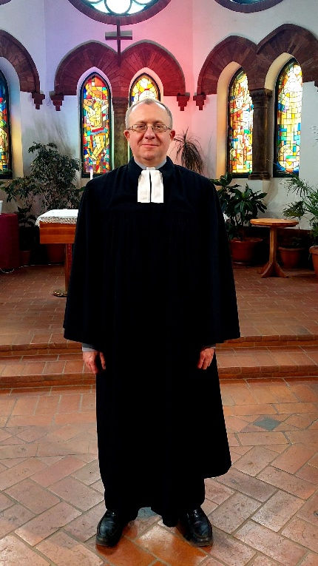
Pictured here is Pastor Vitaly Mohr. Pastor Mohr is the Pastor of St. Paul’s Lutheran Church in the city of Vladivostok in the far east of Russia. The Bishop and members of St. Paul’s speak highly of his ministry and our synod has been asked to help fund his ministry. Therefore, we have the following suggestions for your observance of Russia Sunday.
Consider singing hymn 155 as the Kyrie in your worship on October 5th. That is a version of the Kyrie that comes to us from the Russian Orthodox tradition.
Lift up Pastor Mohr, Bishop Scheiermann and our cousin Christians in Russia in your prayers. This may be Putin’s war in Ukraine and not really the war of the people and Russia might be the aggressor, but it is still causing great suffering among the Russian people. In a recent zoom call we heard that nearly every congregation knows of friends or relatives who were killed or injured in the war in Ukraine. They too need our prayers for comfort and healing.
And finally, do consider making a donation to support the ministry of Pastor Vitaly Mohr and Pastor Alexander Lapochenko or to the companion synod visitation fund to help defray the costs of a visit from Bishop Scheiermann.
And pray for an end to the war in Ukraine so that once again, we can visit, worship and enjoy fellowship with our Russian cousins.

