Opening Worship
Trusting God in the midst of change
Announcements

AFFIRMATION OF BAPTISM
We believe in God’s grace which is the gift of God’s unending love and forgiveness. In our baptisms we are given that gift and become members of God’s family.

Holy God,
We can turn our backs on you, but you will never turn your back on us because we are members of your family. No matter how far we stray from you, you will always welcome us home. You will always love us. Remembering our baptism reassures us our sins are washed away so we can live the free and full lives you created us to live. Amen.

Opening Hymn
ELW 768 Lead Me, Guide Me

Prayer of the Day
Holy God,
You alone are worthy of our praise. When we are overwhelmed with change in our lives and in our church, give us your assurance and strength. You are constant and steadfast. You never change. Give us wisdom, patience, and hope as we discern your call for the church. In Jesus' name we pray.
Amen.

First Reading and DramaIsaiah 55:8-13
For my thoughts are not your thoughts,
nor are your ways my ways, says the Lord.
For as the heavens are higher than the earth,
so are my ways higher than your ways
and my thoughts than your thoughts.
For as the rain and the snow come down from heaven
and do not return there until they have watered the earth,
making it bring forth and sprout,
giving seed to the sower and bread to the eater,
so shall my word be that goes out from my mouth;
it shall not return to me empty,
but it shall accomplish that which I purpose
and succeed in the thing for which I sent it.
For you shall go out in joy
and be led back in peace;
the mountains and the hills before you
shall burst into song,
and all the trees of the field shall clap their hands.
Instead of the thorn shall come up the cypress;
instead of the brier shall come up the myrtle,
and it shall be to the Lord for a memorial,
for an everlasting sign that shall not be cut off.
Gospel: Matthew 18:18-27 It’s not easy to trust Jesus (Bishop Candea)

Sermon

Hymn Be Still My Soul HFW 113

Prayer of Intercession
**We invite you to read the petitions if you are so moved. Please speak loudly. If you find others are praying as well, that is great. Just keep going.

(Bishop Candea with people joining in)So often when we pray, we pray for ourselves, which is good. We also need to remember to pray for others and so we offer our prayer for a world in need.

A brief silence.

God of life, reveal to your church the direction you want us to go. When we are tempted to stand in your way, when we are focused more on things of this world than on you, turn us back to your path for us and for our church. Merciful God,
receive our prayer.

Renew the earth by your Spirit. Challenge us to live humbly and peaceably as part of your creation. Merciful God,
receive our prayer.

We pray for the nations of the world. Topple the dividing walls that separate us from our neighbors. Form us into your beloved community where diversity is celebrated and affirmed. Merciful God,
receive our prayer.

God of justice, equip the Central States Synod to boldly follow you. Guide the work of the church to continue to be a place of love and a church not afraid to risk. Merciful God,
receive our prayer.

Gracious God, we believe that you are big enough and powerful enough to hear all prayers and so we trust that you hear and answer our prayers, today.
Amen.

DIALOGUE
God has prepared a sacred meal for us.
We praise you, O God.

God invites us to this sacred meal; sinner and saint, wounded and healed, weak and strong.
We praise, O God.

PREFACE (based on Romans 1:16-17)
God, you give us food to strengthen us to do the things you need us to do. This meal is sacred because your holy presence is mysteriously infused in what we eat and drink at your table. These nourish us to do your work in our church, in our community and throughout the world. In response to this gift from you, we praise your name and sing…

SANCTUS
ACS 1089
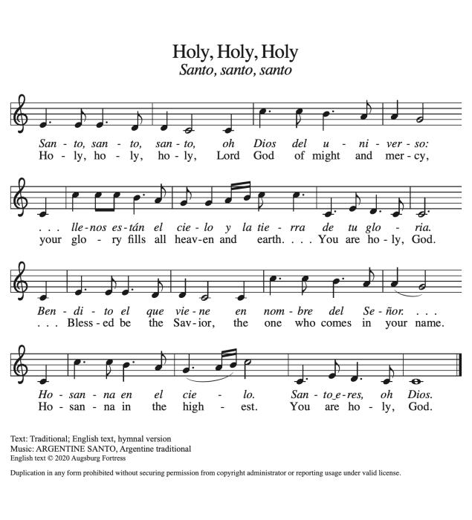
THANKSGIVING AT THE TABLE
We continue to prepare ourselves to receive God’s holy meal by remembering all God has done for us through Jesus Christ, who was not afraid of change. God sent Jesus to show us with compassion the need to change. Jesus taught new ways of understanding and interacting with God. Jesus showed a new way to love through his life, death and resurrection. Through this meal, we receive the presence of Jesus to take with us as we go out into the world to help make God’s vision a reality. Through this meal, we are nourished and strengthened to do what God calls us to do.
Now, we ask Jesus to consecrate or make this bread and cup holy with his presence. It is not magic. It is a great mystery that has been believed and practiced since the first time we participated in this meal with Jesus. Listen to the words that Jesus spoke to the disciples and know that they are spoken for all of us.

On the night in which he was betrayed...

LORD'S PRAYER

INVITATION TO COMMUNION
Jesus Christ is the host of this meal and Jesus welcomes all people. It doesn’t matter if you’re Lutheran or a member of this church. All are welcome at Jesus’ table, so come.

Communion Songs
We are using videos in this part of our worship to bring in a different genre of music from voices of color and in different languages. (You can say that however you feel comfortable.)

Prayer After Communion
Gracious God,
When we participate in this holy meal, we are connected to all who believe throughout the world. We are connected through faith, through your presence and through your mission to share your grace with all we meet. Amen.

Blessing
In the name of God the Creator, Jesus the Redeemer, and the Holy Spirit our sustainer, we are sent out to be God’s church in an ever changing world.
Amen.

Closing Hymn Day by Day (Godspell)
Copyright covered under one license #249211
Dismissal
We have been fed and renewed by Christ. As we go in grace, we shout with joy:
THANKS BE TO GOD!

