PAPUA NEW GUINEA SUNDAY
April 7th, 2024
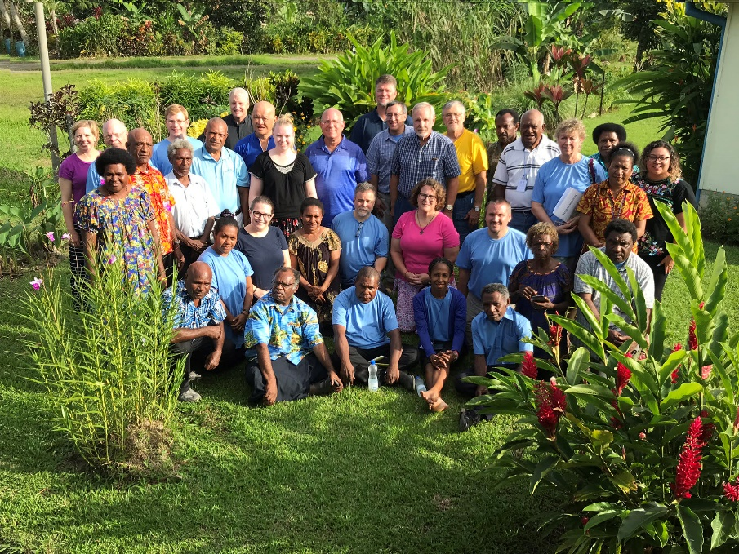
This is the group drawn from the Central States Synod and 3 other synods of the ELCA as well as well as the 4 companion districts of the ELCPNG who gathered for a consultation in 2019
A four-person delegation from the Central States Synod will be traveling to Papua New Guinea in August to participate in a consultation there and visit our companion district. However, there are no funds budgeted by the synod for this purpose. Can you help fund travel to this very important gathering in Papua New Guinea? The consultation will include representation from 3 other synods who have companion districts in PNG as well as representatives from the companion districts and the national church partnership offices of the ELCPNG and the ELCA.
The consultation and visitation is for the purpose of revitalizing our companion church ministries following the covid pandemic. The delegation from the CSS will follow-up on the Sunday School project, build relationship with a new District president following the death of the previous president, explore the possibility of young adults serving as Camp Counselors at Camp Tomah Shinga, as well as other possible areas of partnership in ministry.
. Let me share with you a recent communication from Pastor Erena Waraga, the current president of the Kote District.
Greetings to all of our friends in the USA. God be with you all.
We are currently fighting a plan by a gold mining company called Wapi/Golpu to build a pipeline that will dump mine waste in the waters of the Huon gulf. Our district has joined with the national church in objecting to this plan as it would threaten the waters that are a primary source of food for a great many of our people.
We appreciate the money collected by your synod to help us purchase new Sunday School materials. Our circuits are now working to
raise our portion of the funds so that the materials can be printed. . . Thank you for thinking of us and for your prayers.
Pastor Erena Waraga, president, Kote District,

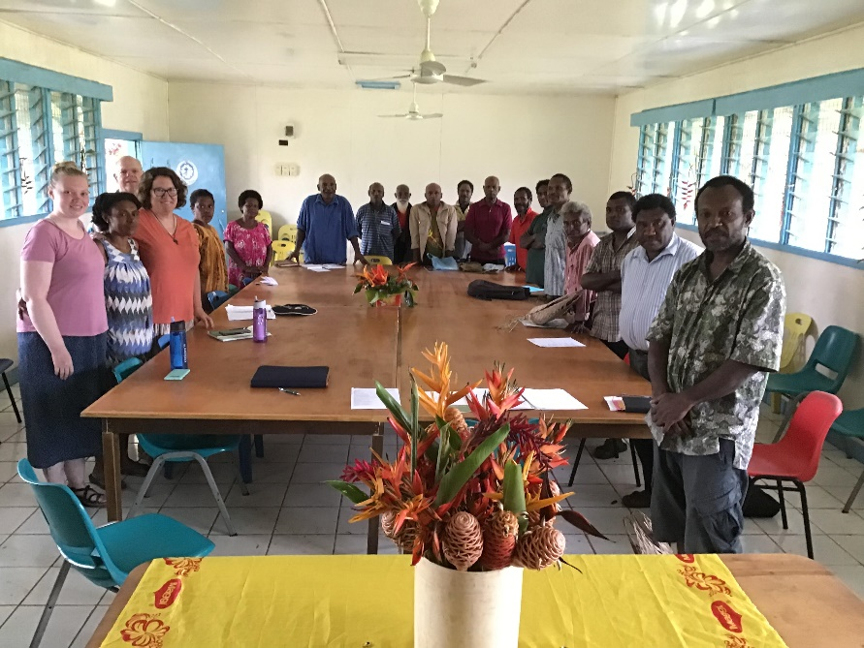
The 2019 visitation team from the Central States Synod with the District Council of the Kote District during discussions about where, when and how we can be partners in ministry.
Please consider a special offering on Papua New Guinea Sunday, April 7th, 2024 designated for Companion Synod Travel.
If your congregation has a mission endowment fund, please let the synod Office know if it would be possible to apply to it for funding for the consultation.
If your congregation has undesignated benevolence, please consider directing it toward the Companion Synod Consultation.
Funds should be sent to the Synod Office designate for Companion Synod Travel, or, Papua New Guinea Consultation.
Please include President Erena Waraga, the people of the Kote District, ELCPNG as well as the people of Papua New Guinea in your personal and congregational prayers, especially on Papua New Guinea Sunday, April 7th, 2024.

